

10/7/2024

**SUBMITTED BY: MARYAM ASIF**

**SAP ID: 65490**

**DEPARTMENT: CYBER SECURITY**

**SEMESTER: 1ST**

**SUBMITTED TO: MA’AM FAREEHA**

PROGRAMING FUNDAMENTAL

Lab#9

TASK#1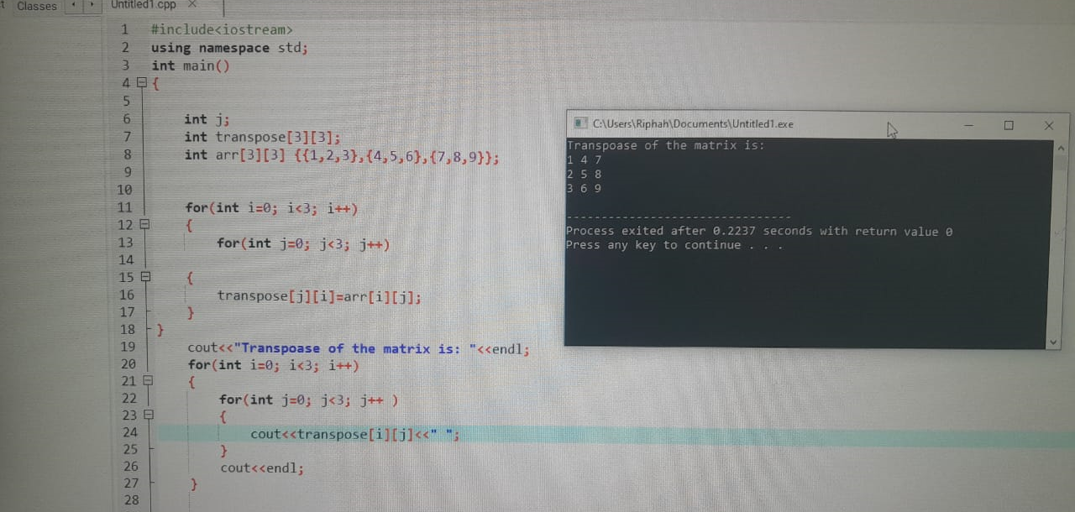

TASK#2

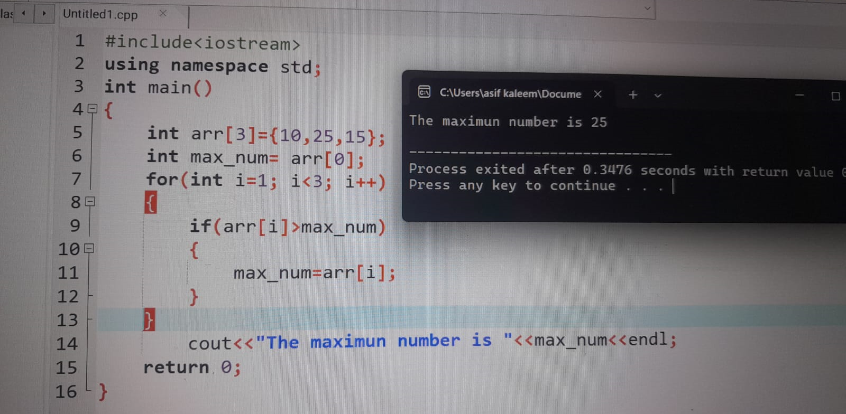

TASK#3

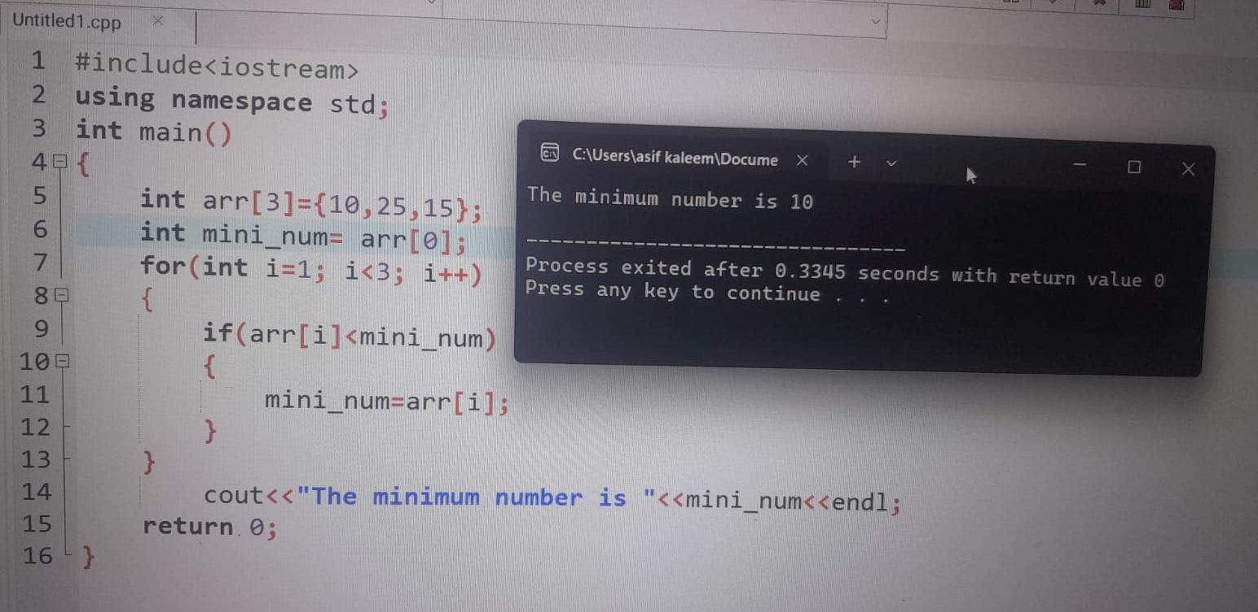

TASK#4

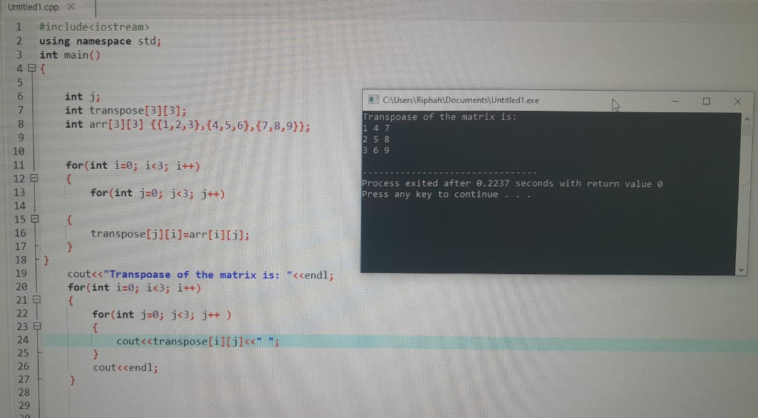

TASK#5

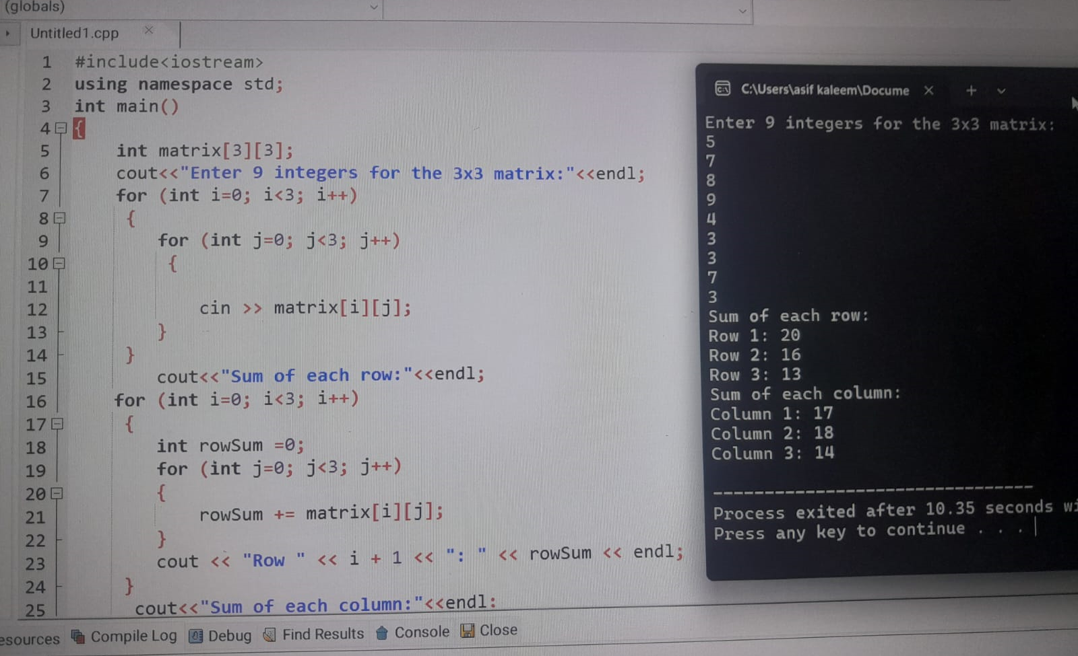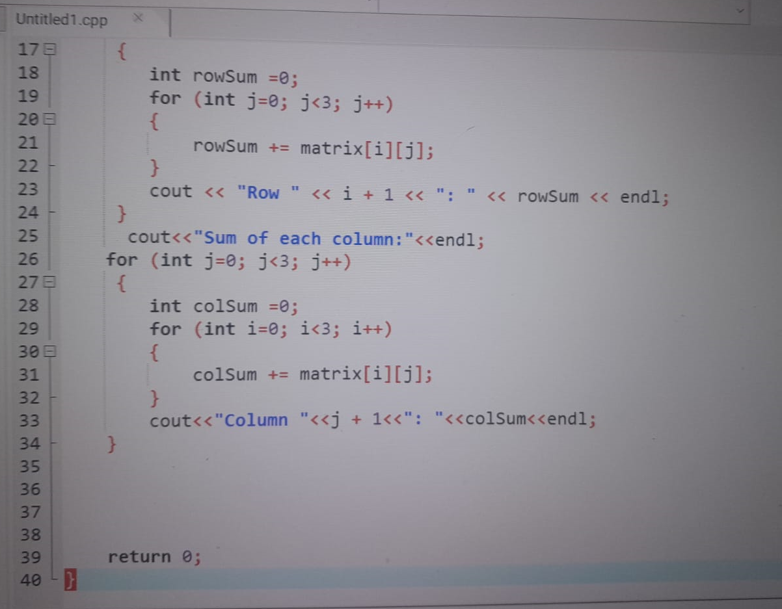

TASK#6

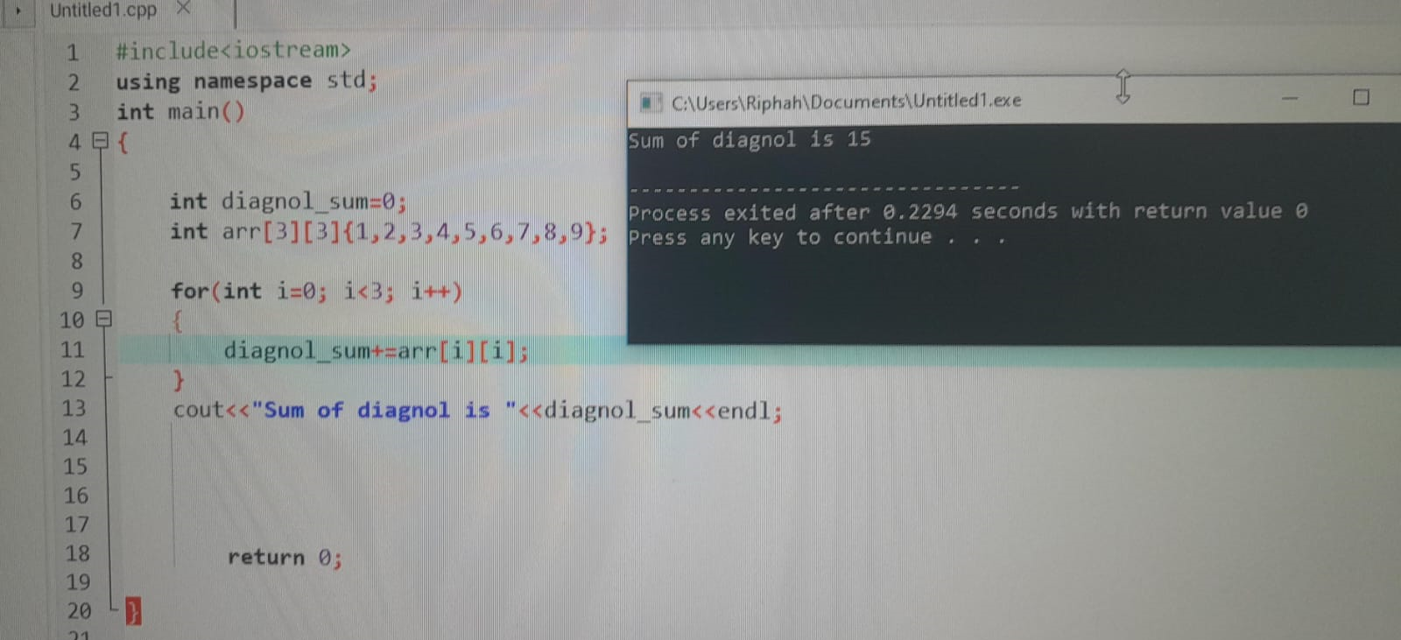

TASK#7

